SINGAPORE POLYTECHNIC
2019/2020 SEMESTER TWO MOCK MST

DIPLOMA IN INFORMATION TECHNOLOGY
FIRST YEAR FULL TIME

BACK-END WEB DEVELOPMENT
Time Allowed: 1 Hour
(Note that the MST is 2 hours with more questions)

Admission Number: __2006264_____________________________ Class: __________DISM/2B/21______
Name: Soh Kai Meng Leonard ________________________________

Instructions to Candidates
- This paper consists of 6 pages (inclusive of the cover page and appendix).
- This is a RESTRICTED OPEN BOOK Test. You may refer to source codes on your laptop only and access the module materials on the Blackboard.

- Do not use any communication software or access any websites on the Internet besides blackboard. Any form of communication online or offline is prohibited. Anyone caught doing so will be considered cheating which may result in failing the module or all the modules, suspension or expulsion.

  - Write your admission number, name and class at the beginning of the every program as comment. Marks will be given for writing your admission number, name and class in every source file that you are required to modify.

- You will be given 5 minutes to:
    - Download BEDPracMockTest.zip from Blackboard and unzip to your local drive. Rename the folder as PYYYYYYMock-CLASS where YYYYYY is your admin number and CLASS is you class eg 1B01.
    - Open the folder and check that you have the following files:

Database | Source Code Files Provided
BEDMockTest.sql  (mysql script provided) | Inside Main Project folder:  - server.js  Inside Model subfolder:  1. module.js  3. databaseConfig.js  Inside Controller subfolder:  1. app.js  (Miscellaneous: Node Modules library and package.json)
- At the end of the test, you are required to:
- Ensure your name, class and admission number are written on all the source files modified. Marks will be deducted if you do not do so.
- Attach the screenshots of the POSTMAN testing of the web apis as indicated in the test instructions below
- Compress the entire “PYYYYYYMock-CLASS” folder and submit through the Blackboard.
- Return the question paper back to the invigilator.

Scenario:

SP requires a back end web service API to store information about modules taught in the school.

The application can be started by running “node server.js”. The database script is provided and you can run it in MySQL workbench to create the database tables.

Note that you are required to modify the following files following the MVC practice. You will be penalized if you do not follow the instructions indicated below:

Model Folder:
- courseModule.js: Contains the logic for the database functions that query/modify the courseModule table in the database
- databaseconfig.js: Contains the database credentials info, thus you are to update the password for your root account if necessary.

Controller Folder:
- app.js: Provide the required API routes and call the model layer modules to query/modify the database tables.

WEB API SPECS:

1)
(40 marks)

Endpoint: GET /courseModule
Request body schema: N/A

Success Response
Code: 200 OK
Content: Module data in the database as below:
[
{
"id": 1,
"name": "Backend Web Development",
"course": "DIT",
"code": "ST0503",
},
{
"id": 2,
"name": "Fundamentals of Programming",
"course": "DIT",
"code": "ST0501",
},
….
]

Error Response(s)
Condition: Any error
Status Code: 500 (Internal Server Error)
Body: {"Result":"Internal Error"}

2)
(40 marks)

Endpoint: POST /courseModule
Request body schema: name, course, code
(Note that registeredData is an auto-generated value in the database, and you should not supply it during the insertion)

Success Response
Code: 201 CREATED
Content: Information on the actual Affected rows. For example below:

{"Affected Rows":"1"}

Error Response(s)
Condition: Any error
Status Code: 500 (Internal Server Error)
Body: {"Result":"Internal Error"}

You are required to take one screenshot for each web api test showing the test data and results of POSTMAN based on the scenarios below. Correctness will be validated with your source code. Remember to attach the screenshots files in a word document file with your name, admin number and class in the document(screenshots.doc) and attach it together with the submission zip file.

3) Retrieve all modules’ data from the courseModule table. (10 marks)
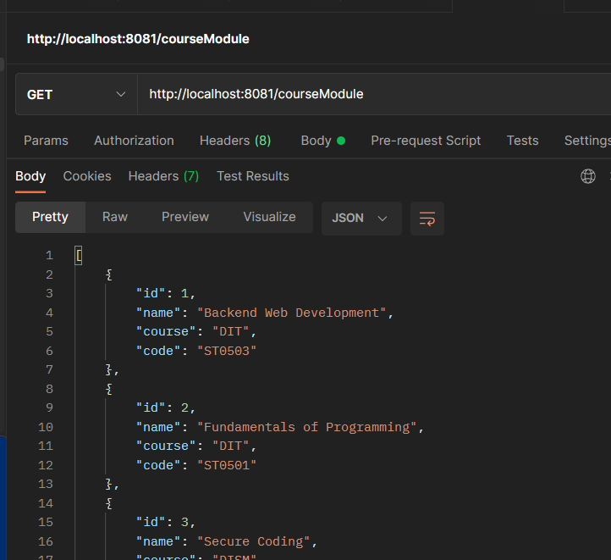

4) Insert a new record in the CourseModule Table with the name: Java Programming, Code: ST1234, course: DIT (10 marks)
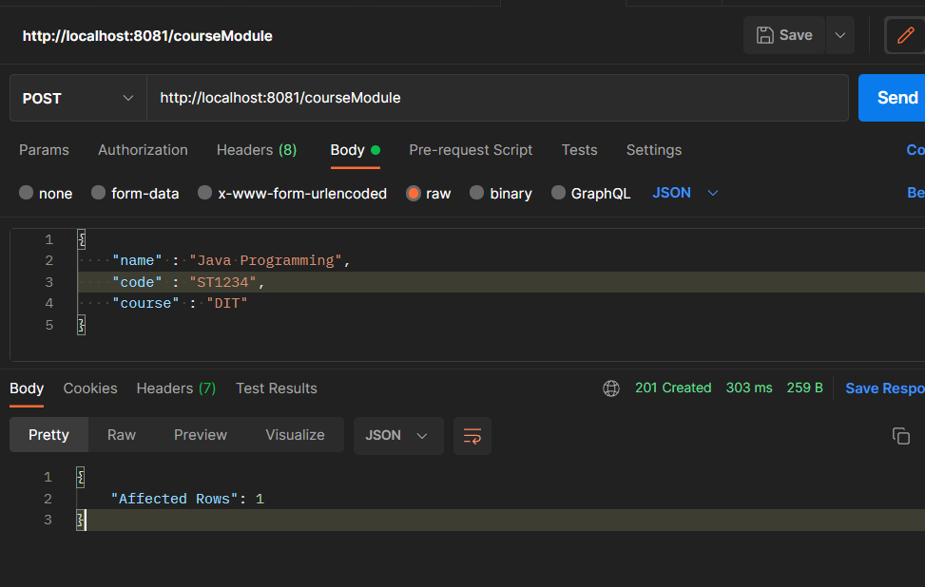

Appendix: Database Table Structure/Schema

Table name: coursemodule
Description: Stores all the modules

Field Name | Data Type | Note
id | INT(11) | Primary Key, Auto-Increment
name | VarChar(100)
course | VarChar(45)
code | VarChar(45)
registeredDate | TimeStamp | Default value is CURRENT_TIMESTAMP  (auto generated value, NOT to be supplied by client)

- End of Paper -

